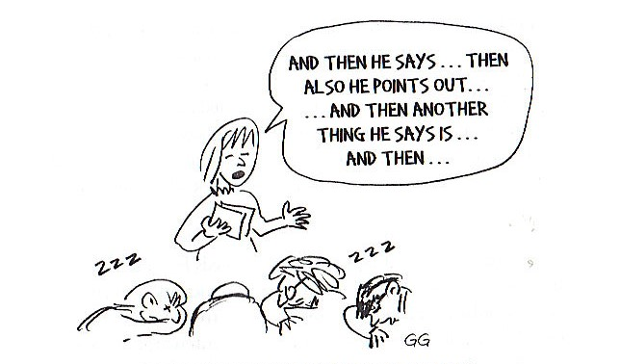
Figure 1. The Effect of a Typical List Summary

Graff & Birkenstein p. 36

